Parish of Wilmcote

NOTICE OF MEETING OF

PARISH COUNCIL
A Meeting of the Parish Council for the above named Parish will be held on the 4th August 2020 at 7.00 p.m.

For the health and well-being of our community as a result of the Covid-19 crisis and following the instruction of the Prime Minister’s address on 23rd March 2020, all Parish Council meetings will be held remotely until further notice using Zoom software. All meetings will be minuted.
Should any resident wish to submit a question to the Parish Council or to participate in the meeting via Zoom, please email the Clerk lizbutterworth1@btinternet.com by 2 pm on Monday 3rd August.

Dated this 28th day of July 2020

Signed:
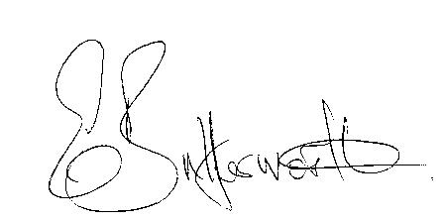Clerk

BUSINESS TO BE TRANSACTED

- Record of Members Present.

- To receive apologies and approve reasons for absence.

- To receive written requests for Disclosable Pecuniary Interests.

- Minutes of the Parish Council meeting held on 20th May 2020 were approved electronically – Chairman to sign.

- Public participation.

- Annual Governance and Accountability Return 2019/20.

a) Section 1 – Annual Governance Statement
b) Section 2 – Accounting Statements

7. Correspondence: All correspondence sent electronically to date will be taken as
read.

9. Date of next meeting to be advised.

