PARISH OF WILMCOTE

A meeting of the Parish Council for the above named Parish will be held at Wilmcote Village Hall on 5th October 2022 at 7.30pm

Dated this 29th day of September 2022
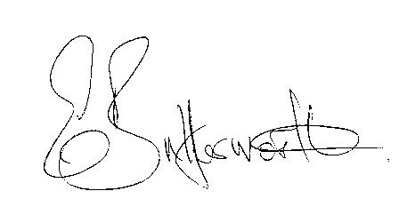Clerk to the Parish Council

BUSINESS TO BE TRANSACTED

- Record of Members Present.

- To receive apologies and approve reasons for absence.

- To receive written requests for Disclosable Pecuniary Interests where that interest is not already in the register of members’ interests.

- To approve for signature the Parish Council meeting held on 20th July 2022 and extraordinary meeting held on 17th August 2022.

- To consider an application for co-option to the Parish Council.

- Public participation.

- County & District Councillor’s reports.

- Planning Applications – status of current planning applications.
To consider planning application No. 22/02236/FUL 6 Marsh Road, Wilmcote:
Demolition of existing dwelling and replacement with a single dwelling to be self-build
and all other associated works.

9. Correspondence received and previously circulated electronically will
be taken as read.

Other communications: The Clerk received a notification from the Keep Fit/Tai Chi leader to say that numbers have reduced since Covid, and the Tai Chi Teacher has decided to retire, so sessions have had to be cancelled. They are very grateful to the Parish Council as without our help and support they would not have been able to continue for this long.
-A resident contacted the Clerk to enquire if it would be possible to put a simple post and wire fence across the access from Arden Close to the Bovis Triangle to discourage access for illegal encampment.
-Defibrillator recall.

10. Community Speedwatch update.

11. Willow Wood Play Area update.

12. Pathlow Park Travellers Site update and Dunroaming site update.

13. Footway lights – update.

14. Parish Council external Audit for 2021/2022.

15. Councillors’ reports and items for the agenda for the next meeting.

16. Date of next meeting: 23rd November 2022

