Parish of Wilmcote

NOTICE OF MEETING OF

PARISH COUNCIL

NOTICE IS HEREBY GIVEN THAT -
A Meeting of the Parish Council for the above named Parish will be held at
Wilmcote Village Hall on the 15th March 2017 at 7.30 p.m.

Dated this 9th day of March 2017

Signed:
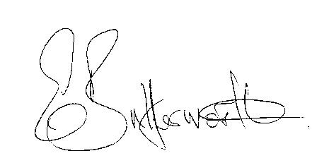Clerk

BUSINESS TO BE TRANSACTED

- Record of Members Present.

- To receive apologies and approve reasons for absence.

- To receive written requests for Disclosable Pecuniary Interests where that interest is not already in the register of members’ interests.

- To approve for signature the Minutes of the meeting held on 18th January 2017.

- Public participation.

- County & District Councillor’s reports. For information only. Unless known in advance items raised for a decision will appear on the next agenda.

- Planning Matters – status of current planning applications.

- Progress reports - for information only and items not on the agenda.

- Correspondence received:

- Details of White Paper “Fixing our broken housing market”.
- Scam Alert–workmen charging a fortune to remove moss from roofs
- WALC notification that the S137 limit for 2017-18 is £7.57
- Letter from Village Hall Committee regarding plans to refurbish and modernise the toilets at the Village Hall.

- Willow Wood Play Area - update:

- Defibrillators – update:

- Neighbourhood Plan – progress:

- Road Traffic Items:
a) School safety zone progress.
b) Community Speedwatch Scheme progress.

- Payment of outstanding invoices.

- Councillors’ reports and items for the agenda for the next meeting.

- Date of next meeting: 17th May 2017. Annual General Meeting followed by ordinary Parish Council meeting.

