Parish of Wilmcote

NOTICE OF MEETING OF

PARISH COUNCIL

NOTICE IS HEREBY GIVEN THAT -
A Meeting of the Parish Council for the above named Parish will be held at
Wilmcote Village Hall on the 15th July 2015 at 7.30 p.m.

Dated this 9th day of July 2015

Signed:
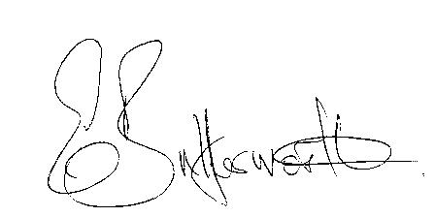Clerk

BUSINESS TO BE TRANSACTED

- Record of Members Present.

- To receive apologies and approve reasons for absence.

- To consider requests from Mrs. K. Shilvock and Mr. C. Lowis to be co-opted onto the Parish Council.

- To receive written requests for Disclosable Pecuniary Interests where that interest is not already in the register of members’ interests.

- Declarations of dispensations granted for Disclosable Pecuniary Interests already in the register of Members Interests.

- To approve for signature the Minutes of the meeting held on 20th May 2015.

- Public participation.

- County & District Councillor’s reports. For information only. Unless known in advance items raised for a decision will appear on the next agenda.

- Parish Council procedures for the benefit of new members, and delegation of Lead Councillors.

- Bank Mandate: an amended mandate is required due to errors/omissions on the form completed at the previous meeting.

- Road Traffic Items.

- Neighbourhood Plan update.

- Planning Applications – status of current planning applications.

To consider Planning Application No. 15/02251/FUL Lime House, Church Road, Wilmcote: Redevelopment of existing dwelling to increase first floor area and re- planning of ground floor.

- Progress reports - for information only and items not on the agenda.

- Correspondence received:

- Information about the National Rural Crime Network.
- £400,000 community energy grant funding: energyshare has partnered with M&S Energy to run their first ever Community Energy Fund, a competition to distribute up to £400,000 in grants to renewable energy projects that benefit the community.

- Willow Wood Play Area: Update & vandalism.

- Planning Consultant report and invoice regarding Planning Application No. 15/0122/FUL 165 Aston Cantlow Road.

- Stratford on Avon Draft Core Strategy update.

- Payment of outstanding invoices.

- Councillors’ reports and items for the agenda for the next meeting.

- Date of next meeting: 16th September 2015.

