Parish of Wilmcote

NOTICE OF MEETING OF

PARISH COUNCIL

NOTICE IS HEREBY GIVEN THAT -
A Meeting of the Parish Council for the above named Parish will be held at
Wilmcote Village Hall on the 15th November 2017 at 7.30 p.m.

Dated this 9th day of November 2017

Signed:
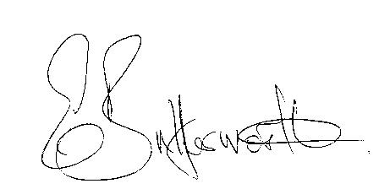Clerk

BUSINESS TO BE TRANSACTED

- Record of Members Present.

- To receive apologies and approve reasons for absence.

- To receive written requests for Disclosable Pecuniary Interests where that interest is not already in the register of members’ interests.

- Co-option of two Parish Councillors.

- To approve for signature the Minutes of the Parish Council meeting held on 20th September 2017.

- Public participation.

- County & District Councillor’s reports. For information only. Unless known in advance items raised for a decision will appear on the next agenda.

- Planning Applications – status of current planning applications.
To consider Planning Application No. 17/03130/FUL Mary Arden Inn, The Green, Wilmcote: A new entrance canopy with new glazed doors, a small flat roof extension cedar clad externally, cedar cladding to an existing will by entrance.

- Correspondence received:
- Budget Capping (Referendum Principles)/Disqualification Criteria Consultations.
- Warwickshire County Council Trading Standards Service Briefing document.

- Wilmcote Parish Council Emergency Plan

- Progress report.

- Willow Wood Play Area update.

- Neighbourhood Plan update.

- Road Traffic items.
a) Update for Community Speedwatch Scheme.
b) School safety zone.
c) Vehicles parking on pavement near railway station.

- Payment of outstanding invoices.

- Councillors’ reports and items for the agenda for the next meeting.

- Date of next meeting: 17th January 2018.

