PARISH OF WILMCOTE

A meeting of the Parish Council for the above named Parish will be held in Wilmcote Village Hall on 15th November 2023 at 7.30 pm.

Dated this 10th day of November 2023
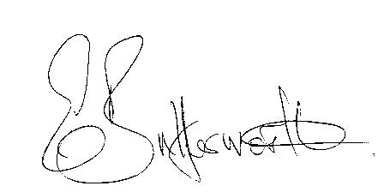Clerk to the Parish Council

BUSINESS TO BE TRANSACTED.
1. Record of Members present.

2. To receive apologies and approve reasons for absence.

3. To receive written requests for Disclosable Pecuniary interests in items on
the agenda.

4. To approve for signature the minutes of the Parish Council meeting
held on 20th September 2023.

5. Public participation.

6. County and District Councillor reports.

7. Status of current planning applications and to consider the following:

Planning application no. 23/02905/LDE 34 Aston Cantlow Rod, Wilmcote:
Confirmation that the single garage shown on application no. 91/00842/FUL
is still extant and can be erected.

Planning application no. 23/02433/LDP 4 Church Road, Wilmcote stationing of
3.96 x 12.19 caravan, within the definition of a caravan in the Caravan Sites and
Control Act 1960 (as amended) within the garden as ancillary to the
accommodation of the dwelling house.

8. Correspondence received and previously circulated will be taken as read.

9. Mary Arden Inn

10. Willow Wood Play Area.

11. Community Speedwatch update.

12. Pathlow Park Traveller Site update.

13. Councillors’ reports and items for the agenda for the next meeting.

14. Date of next meeting: 24th January 2024.

