Parish of Wilmcote

NOTICE OF MEETING OF

PARISH COUNCIL

NOTICE IS HEREBY GIVEN THAT -
A Meeting of the Parish Council for the above named Parish will be held at
Wilmcote Village Hall on the 16th January 2019 at 7.30 p.m.

Dated this 10th day of January 2019

Signed:
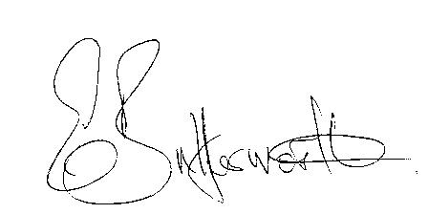Clerk

BUSINESS TO BE TRANSACTED

- Record of Members Present.

- To receive apologies and approve reasons for absence.

- To receive written requests for Disclosable Pecuniary Interests where that interest is not already in the register of members’ interests.

- To approve for signature the Minutes of the Parish Council meeting held on 19th September 2018.

- Public participation.

- County & District Councillor’s reports. For information only. Unless known in advance items raised for a decision will appear on the next agenda.

- Planning Applications – status of current planning applications.

- Future process for use of Planning Consultant and consideration of type of brief to be provided – update from Cllr. Shilvock.

- Correspondence received:

- Charging of Parish Council Elections for May 2019.
- Councils VASA funding bid. Request for funding for transport.
- Annual mid-year population estimates.
- Reassurance provided that local policing will be unaffected by alliance changes.

- Progress report.

- Final Precept request 2019/2020.

- S137 grants.

- Broadband. SDC has advised that the Council is committed to assisting the provision of improved Broadband connectivity for our communities.

- Notice board quotation for consideration.

- Wilmcote Parish Council Procurement Policy.

- Future Investments in the Parish:

- Willow Wood Play Area update:
Annual Inspection report.
Progress on new roundabout.
Equipment purchasing protocol.
New 6 year Lease for signature

- Road Traffic items.
a) Update for Community Speedwatch Scheme.
b) Car parking.
c) Speed limits throughout the village.
d) A3400 speed survey carried out 31st August to 7th September 2018

- Payment of outstanding invoices.

- Councillors’ reports and items for the agenda for the next meeting.

- Date of next meeting: 20th March 2019. Annual Parish meeting followed by ordinary Parish Council meeting.

