Parish of Wilmcote

NOTICE OF MEETING OF

PARISH COUNCIL

NOTICE IS HEREBY GIVEN THAT -
A Meeting of the Parish Council for the above named Parish will be held at
Wilmcote Village Hall on the 16th May 2018 at 7.30 p.m. following the Annual General Meeting.

Dated this 10th day of May 2018

Signed:
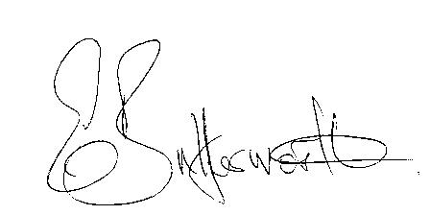Clerk

BUSINESS TO BE TRANSACTED

- Record of Members Present.

- To receive apologies and approve reasons for absence.
- To receive written requests for Disclosable Pecuniary Interests where that interest is not already in the register of members’ interests.

- To approve for signature the Minutes of the Annual Parish meeting and ordinary Parish Council meeting on 21st March 2018.

- Public participation.

- County & District Councillor’s reports. For information only. Unless known in advance items raised for a decision will appear on the next agenda.

- Annual Accounts of Wilmcote Parish Council for 2017/18.

- Planning Applications – status of current planning applications.

- Progress reports - for information only and items not on the agenda.

- Correspondence received:

- WALC notification of revised pay-scales to be implemented from 1st April 2018.
- Copy of Village Hall accounts year ending 31st December 2017 for information.
- The Queens Award for Voluntary Services invitation.
- Advance notification of Cycle Event.
- Grant funding opportunity – Armed Forces Covenant Fund Trust.

- Insurance renewal invitation.

- Willow Wood Play Area - recent issues and general update

- New Data Protection Laws guidance – report Cllr. Lowis

- Traveller issues.

- Councillor participation and responsibilities.

- Payment of outstanding invoices.

- Councillors’ reports and items for the agenda for the next meeting.

- Date of next meeting: 18th July 2018. Venue: Aston Cantlow Village Hall.

