Parish of Wilmcote

NOTICE OF MEETING OF

PARISH COUNCIL

NOTICE IS HEREBY GIVEN THAT -
A Meeting of the Parish Council for the above named Parish will be held at
Wilmcote Village Hall on the 16th September 2015 at 7.30 p.m.

Dated this 10th day of September 2015

Signed:
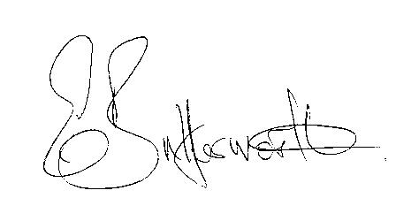Clerk

BUSINESS TO BE TRANSACTED

- Record of Members Present.

- To receive apologies and approve reasons for absence.

- To receive written requests for Disclosable Pecuniary Interests where that interest is not already in the register of members’ interests.

- Declarations of dispensations granted for Disclosable Pecuniary Interests already in the register of Members Interests.

- To approve for signature the Minutes of the meeting held on 15th July 2015.

- Public participation.

- County & District Councillor’s reports. For information only. Unless known in advance items raised for a decision will appear on the next agenda.

- Parish Council procedures for the benefit of new members, and delegation of Lead Councillors.

- Road Traffic Items.

- Neighbourhood Plan update.

- Planning Applications – status of current planning applications.

To consider Planning Application No. 15/02889/FUL 22B Aston Cantlow Road, Wilmcote: Demolition of existing single storey rear extension and erection of replacement single storey rear extension.

- Progress reports - for information only and items not on the agenda.

- Correspondence received:

- Distance Learning Modules, a wealth of information for Councillors at all levels.
- Warwickshire County Council Lengthsman Scheme – expressions of interest requested by the end of September 2015.
- Combined Authorities Consultation – deadline 24th July 2015.
- Independent Advisory Groups – Critical Friends of the Police.

- Willow Wood Play Area: Update & to consider what action to take regarding the split swing bay post.

- Combined Authorities Consultation update.

- Stratford on Avon Draft core Strategy update.

- Payment of outstanding invoices.

- Councillors’ reports and items for the agenda for the next meeting.

- Date of next meeting: 18th November 2015.

