PARISH OF WILMCOTE

NOTICE OF ORDINARY PARISH COUNCIL MEETING FOLLOWING THE ANNUAL MEETING

Dated this 12th day of March 2021
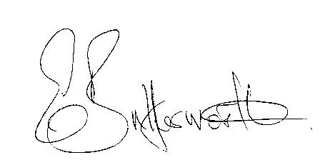Clerk to the Parish Council

BUSINESS TO BE TRANSACTED

- Record of Members Present.

- To receive apologies and approve reasons for absence.

- To receive written requests for Disclosable Pecuniary Interests.

- To approve for signature the minutes of the Parish Council meeting held on 27th January 2021 and extraordinary meeting held on 5th March 2021.

- Public participation:

7. Correspondence: All correspondence sent electronically to date will be taken as
read.

8. County and District Councillor reports.

9. Planning applications – status of current applications.

10. Road Traffic items update.

11. Willow Wood playground: Consideration of quotations for replacement equipment.

12. Review of Financial regulations. Review team

13. Review of Emergency Plan.

14. Training in use of Defibrillator.

15. Environmental initiatives.

16. Review of entire Standing Orders.

17. Review of Lead Councillors and responsibilities.

18. Report from Cllr. Simmons providing suggestions on how Parish Online is used for
Parish Council initiatives/information and specific responsibilities.

19. Items for the agenda for the next meeting.

20. Date of next meeting to be advised.

