Parish of Wilmcote

NOTICE OF MEETING OF

PARISH COUNCIL

NOTICE IS HEREBY GIVEN THAT -
A Meeting of the Parish Council for the above named Parish will be held at
Wilmcote Village Hall on the 17th May 2017 following the Annual General meeting.

Dated this 11th day of May 2017

Signed:
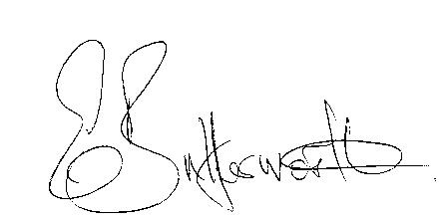Clerk

BUSINESS TO BE TRANSACTED

- Record of Members Present.

- To receive apologies and approve reasons for absence.
- To receive written requests for Disclosable Pecuniary Interests where that interest is not already in the register of members’ interests.

- To approve for signature the Minutes of the Annual Parish and ordinary Parish Council meetings on 15th March 2017.

- Public participation.

- County & District Councillor’s reports. For information only. Unless known in advance items raised for a decision will appear on the next agenda.

- Annual Accounts of Wilmcote Parish Council for 2016/17.

- Planning Applications – status of current planning applications.

- Progress reports - for information only and items not on the agenda.

- Correspondence received:
- NALC consultation on Government Housing White Paper
- UBUS Community Transport Service information.
- Flood Risk Management Newsletter.
- Notification of The Great Get Together on 17th & 18th June 2017
- Nationwide event to find Britain’s Best Village.
- Code of Conduct Review timetable.
- Advance notification of Mr. Whitfield’s intention to submit a revised planning application for some of the land at The Orchards, Station Road, Wilmcote.

- Community Infrastructure Levy.

- Willow Wood Play Area update.

- Neighbourhood Plan update.

- Road Traffic items. Update for Community Speedwatch Scheme and school safety zone.

- Parish Council Emergency box and Defibrillators update.

- Payment of outstanding invoices.

- Councillors’ reports and items for the agenda for the next meeting.

- Date of next meeting: 19th July 2017.

