PARISH OF WILMCOTE

A meeting of the Parish Council for the above named Parish will be held on 17th November 2021 at 7.30pm in Wilmcote Village Hall

Dated this 10th day of November 2021
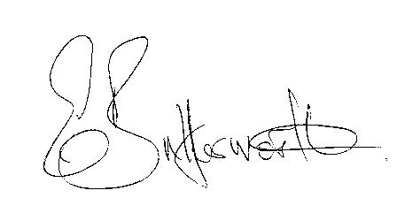Clerk to the Parish Council

BUSINESS TO BE TRANSACTED

- Record of Members Present.

- To receive apologies and approve reasons for absence.

- To receive written requests for Disclosable Pecuniary Interests.

- Councillor resignations.
School Trust Fund.

- To approve for signature the minutes of the ordinary Parish Council meeting held on 22nd September 2021.

- Public participation.

- County & District Councillor reports.

8. Correspondence: All correspondence sent electronically to date will be taken as
read by all Councillors.

Additional Correspondence received from a resident in Glebe Estate regarding parking issues.

9 Lead Councillors: Councillor responsibility areas updated.

10. Planning applications – status of current applications.

11. Standing Orders: a) Lone Worker Policy.
b) Public participation at meetings.
c) Personal safety for elected members.

12. Willow Wood playground update: Annual inspection report.

13. Mary Arden Inn update.

14. Road Safety Items update: Subject to receipt of plans for suggested revised location and sign being received from Graham Staley, WCC

15. HSBC Bank advisory on changes to community accounts.

16. E.on footway lighting – to consider renewing columns and brackets to accommodate LEDs

17. S137 Grant applications for 2021/22

18. Pathlow Park Travellers site update.

19. Parish Online – renewal due in January 2022.

20. Community Speedwatch team update.

21. Edkins Park update.

22. Items for the agenda for the next meeting.

23. Date of next meeting: 19th January 2022.

