Parish of Wilmcote

NOTICE OF MEETING OF

PARISH COUNCIL

NOTICE IS HEREBY GIVEN THAT -
A Meeting of the Parish Council for the above named Parish will be held at
Wilmcote Village Hall on the 18th January 2017 at 7.30 p.m.

Dated this 11th day of January 2017

Signed:
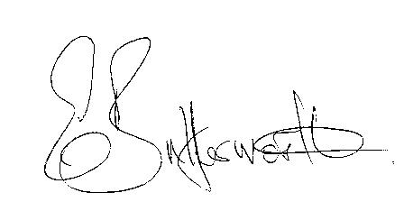Clerk

BUSINESS TO BE TRANSACTED

- Record of Members Present.

- To receive apologies and approve reasons for absence.

- To receive written requests for Disclosable Pecuniary Interests where that interest is not already in the register of members’ interests.

- To approve for signature the Minutes of the Parish Council meeting held on 16th November 2016.

- Public participation.

- County & District Councillor’s reports. For information only. Unless known in advance items raised for a decision will appear on the next agenda.

- Planning Matters – status of current planning applications.

To re-consider planning application No. 16/03366/FUL Stone Cottage, Old School Lane, Wilmcote: Construction of a sliding gate.

- Progress reports - for information only and items not on the agenda.

- Correspondence received:
- WALC advisory – Defamation and Social Media.
- WALC - Nominations for Attendance at a Royal Garden Party.
- WALC training information.
- Warwickshire Minerals Plan (2017-2032) Publication Consultation.
- Tiffin Club Event, Friday 27th January, Warwick Castle.
- Warwickshire Fire & Rescue Service Integrated Risk Management Plan 2017 – 2020
- Warwickshire Police and Crime Panel - Independent Member Vacancy

- Willow Wood Play Area update.

- Precept for 2017/18.

- Defibrillators – update.

- Emergency Plan revisions.

- Neighbourhood Plan update.

- Councillors’ individual responses to planning applications.

- Road Traffic items: school safety zone - results of traffic data survey.

- Recording Assets of Community Value.

- Payment of outstanding invoices.

- Councillors’ reports and items for the agenda for the next meeting.

- Date of next meeting: 15th March 2017.

