Parish of Wilmcote

NOTICE OF MEETING OF

PARISH COUNCIL

NOTICE IS HEREBY GIVEN THAT -
A Meeting of the Parish Council for the above named Parish will be held at
Wilmcote Village Hall on the 18th March 2020 at 7.30 p.m.

Dated this 12th day of March 2020

Signed:
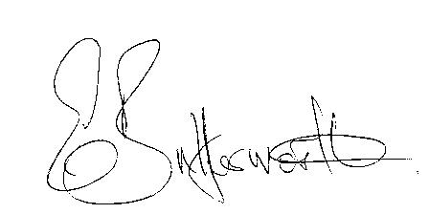Clerk

BUSINESS TO BE TRANSACTED

- Record of Members Present.

- To receive apologies and approve reasons for absence.

- To receive written requests for Disclosable Pecuniary Interests where that interest is not already in the register of members’ interests.

- To approve for signature the Minutes of the Parish Council meeting held on 22nd January 2020.

- Public participation.

- County & District Councillor’s reports. For information only.

- Planning Applications – status of current planning applications.
To consider the following Planning Applications:
20/00595/FUL 29 Swanfold, Wilmcote: Garage conversion with raised roof line and internal alterations.
20/00727/TREE 13 Aston Cantlow Road, Wilmcote: Fell Ash tree.

8. Correspondence received:

- Survey: Community Safety in Warwickshire
- Consultation Day with Warwickshire County Council
- SDC Member Briefing: Exploitation awareness.
- Advance details of date for Three Tier Event – 16th July and the
theme is Climate Change.

9. Progress report.

10. Campaign for the Local Electricity Bill.

11. Mary Arden’s Farm overflow car park proposals: To receive report
on sub-group meeting with Abi Moore, Mark Ratcliffe and Cllr. Shenton held on 17th February 2020

12. S137 Grant applications procedure.

13. Willow Wood Play Area update.

14. Emergency Plan review.

15. Defibrillator training.

16. Road Traffic items.
a) Report from Traffic Working Group.
b) Update for Community Speedwatch Scheme.
b) School safety zone update.
c) ANPR cameras

17. Councillors’ reports and items for the agenda for the next meeting.

18. Date of next meeting: 20th May 2020. Annual Parish Council meeting followed by an ordinary meeting.

