Parish of Wilmcote

NOTICE OF MEETING OF

PARISH COUNCIL

NOTICE IS HEREBY GIVEN THAT -
A Meeting of the Parish Council for the above named Parish will be held at
Wilmcote Village Hall on the 18th May 2016 at 7.30 p.m. following the Annual General Meeting.

Dated this 10th day of May 2016

Signed:
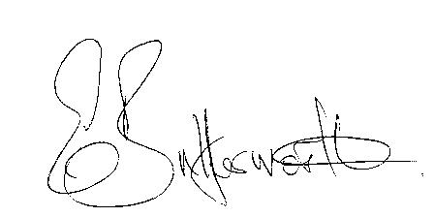Clerk

BUSINESS TO BE TRANSACTED

- Record of Members Present.

- To receive apologies and approve reasons for absence.

- To receive written requests for Disclosable Pecuniary Interests where that interest is not already in the register of members’ interests.

- To approve for signature the Minutes of the Annual Parish and ordinary Parish Council meetings on 23rd March 2016.

- Public participation.

- County & District Councillor’s reports. For information only. Unless known in advance items raised for a decision will appear on the next agenda.

- Annual Accounts of Wilmcote Parish Council for 2015/16.

- Planning Applications – status of current planning applications.
To consider Planning Application No. 16.01409/AGNOT Gypsy Hall Farm, Aston Cantlow Road, Wilmcote: Machinery and tool store.

- Progress reports - for information only and items not on the agenda.

- Correspondence received:
- Consultation on Main Modifications to Stratford-on-Avon District.
Submission Core Strategy 2014
- Election notices: Police & Crime Commissioner – statement of persons nominated.
- Consultation: Proposed changes to planning process.

- Lime Tree on the Green. Quotation for work required in accordance with our risk assessment schedule.

- Standing Orders: To include Parish Council procedure relating to proposals ahead of formal consultation notices from SDC.

- Willow Wood Play Area: To consider quotations received for replacement equipment and agree a plan to manage the play area in the longer term.

- Neighbourhood Plan update.

- Road Traffic items.

- Parish Council Emergency box.

- Payment of outstanding invoices.

- Councillors’ reports and items for the agenda for the next meeting.

- Date of next meeting: 20th July 2016.

