Parish of Wilmcote

NOTICE OF MEETING OF

PARISH COUNCIL

NOTICE IS HEREBY GIVEN THAT -
A Meeting of the Parish Council for the above named Parish will be held at
ASTON CANTLOW VILLAGE HALL on the 18th July 2018 at 7.30 p.m.

Dated this 12th day of July 2018

Signed:
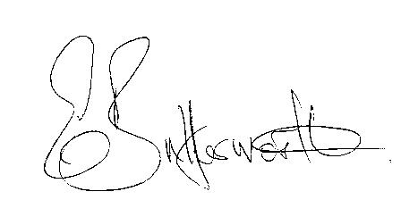Clerk

BUSINESS TO BE TRANSACTED

- Record of Members Present.

- To receive apologies and approve reasons for absence.

- To receive written requests for Disclosable Pecuniary Interests where that interest is not already in the register of members’ interests.

- To approve for signature the Minutes of the Annual General meeting and ordinary Parish Council meetings held on 16th May 2018.

- Abi Moore and Mark Ratcliffe, Shakespeare Birthplace Trust, to update the Parish Council regarding the proposals for extra car parking facilities.

- Public participation.

- County & District Councillor’s reports. For information only. Unless known in advance items raised for a decision will appear on the next agenda.

- Planning Applications – status of current planning applications.

- Correspondence received:

-2018 Model Standing Orders – changes
- Notification of launch of County Councillors’ grant fund.

- Progress report.

- Authorisation for the Proper Officer to grant dispensations when required.

- Standing Orders review: Appendix ll – risk register and Appendix lll Asset register. Update regarding data protection procedure.

- Quarterly financial statement.

- Willow Wood Play Area update.

- Road Traffic items.
a) Update for Community Speedwatch Scheme.
b) School safety zone.
c) Vehicles parking on pavement near railway station.

- Payment of outstanding invoices.

- Councillors’ reports and items for the agenda for the next meeting.

- Date of next meeting: 19th September 2018.

