Parish of Wilmcote

NOTICE OF MEETING OF

PARISH COUNCIL

NOTICE IS HEREBY GIVEN THAT -
A Meeting of the Parish Council for the above named Parish will be held at
Wilmcote Village Hall on the 18th November 2015 at 7.30 p.m.

Dated this 12th day of November 2015

Signed:
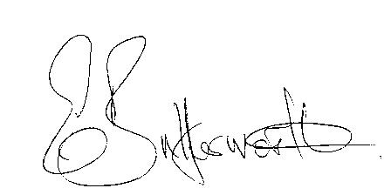Clerk

BUSINESS TO BE TRANSACTED

- Record of Members Present.

- To receive apologies and approve reasons for absence.

- To receive written requests for Disclosable Pecuniary Interests where that interest is not already in the register of members’ interests.

- Declarations of dispensations granted for Disclosable Pecuniary Interests already in the register of Members Interests.

- Presentation of intent to apply for outline planning permission in The Orchards off Station Road. Mr. A. Whitfield and Mr. G. Moss.

- To approve for signature the Minutes of the meeting held on 16th September 2015 and Special Meeting held on 15th October 2015.

- Public participation.

- County & District Councillor’s reports. For information only. Unless known in advance items raised for a decision will appear on the next agenda.

- Pathlow Park Traveller Site including adjacent public footpath.

- Road Traffic Items.

- Appointment of Vice Chairman

- Planning Applications – status of current planning applications.

- Progress reports - for information only and items not on the agenda.

- Correspondence received:

- CIL Submission Charging Schedule – deadline 13th November.
- Warwickshire County Council - Minerals Plan – Preferred Option & Policies. Consultation deadline 4th December 2015. Received via disc.
- Important Notice: Confirming your Tax Status.

- Parish Council Standing Orders – Councillors’ required method for responding to planning application consultations.

- Clerk’s expenses in relation to Broadband connection.

- Draft Precept

- Willow Wood Play Area Update. Discussion document circulated.

- Neighbourhood Plan Update.

- Stratford on Avon Draft Core Strategy update.

- Bank Mandate: Incorrect mandate previously provided by HSBC. New mandate to be completed.

- Payment of outstanding invoices.

- Councillors’ reports and items for the agenda for the next meeting.

- Date of next meeting: 27th January 2016.

