Parish of Wilmcote

NOTICE OF MEETING OF

PARISH COUNCIL
A Meeting of the Parish Council for the above named Parish will be held on the 18th November 2020 at 7.00 p.m.

For the health and well-being of our community as a result of the Covid-19 crisis and following the instruction of the Prime Minister’s address on 23rd March 2020, all Parish Council meetings will be held remotely until further notice using Zoom software. All meetings will be minuted.
Should any resident wish to submit a question to the Parish Council or to participate in the meeting via Zoom, please email the Clerk lizbutterworth1@btinternet.com by 2 pm on Monday 16th November.

Dated this 12th day of November 2020

Signed:
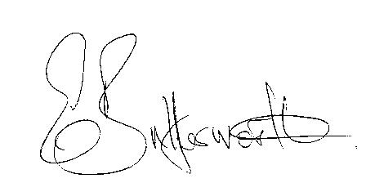Clerk

BUSINESS TO BE TRANSACTED

- Record of Members Present.

- To receive apologies and approve reasons for absence.

- Councillor resignation.

- To receive written requests for Disclosable Pecuniary Interests.

- To approve for signature the minutes of the Parish Council meeting held on 30th September 2020.

- Public participation.

7. Correspondence: All correspondence sent electronically to date will be taken as
read.

8. County and District Councillor reports.

9. Planning applications – status of current applications.
To consider application No.20/02899/FUL Field House, 8 Manor Drive, Wilmcote: Proposed balcony to the rear of a dwelling (retrospective).

Land belonging to Heart of England Forests

10. Draft Precept for consideration.

11. Wilmcote Parish Council S137 grant applications for consideration.

12. Memorial bench.

13. Road traffic items
a) Church Road safety.
b) Area between train station and canal entrance.

14. Willow Wood playground
a) Annual inspection report circulated.

17. Items for the agenda for the next meeting.

18. Date of next meeting 27th January 2021

