PARISH OF WILMCOTE

A meeting of the Parish Council for the above named Parish will be held on 19th January 2022 at 7.30pm at Wilmcote Village Hall

Dated this 13th day of January 2022
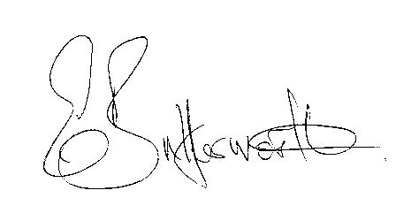Clerk to the Parish Council

BUSINESS TO BE TRANSACTED

- Record of Members Present.

- To receive apologies and approve reasons for absence.

- To receive written requests for Disclosable Pecuniary Interests.

- To approve for signature the previously circulated minutes of the ordinary Parish Council meeting held on 17th November 2022.

- Public participation.

6. To formally agree the precept request for 2022/2023. A proposal was circulated to Councillors
for consideration ahead of the meeting.

7. Date of next meeting: 23rd March 2022.

DUE TO THE CURRENT COVID SITUATION THIS WILL BE A VERY SHORT MEETING AND WILL BE HELD OUTSIDE IN THE CAR PARK.

