Parish of Wilmcote

NOTICE OF MEETING OF

PARISH COUNCIL

NOTICE IS HEREBY GIVEN THAT -
A Meeting of the Parish Council for the above named Parish will be held at
Wilmcote Village Hall on the 19th July 2017 at 7.30 p.m.

Dated this 13th day of July 2017

Signed:
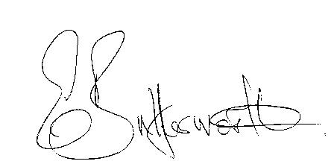Clerk

BUSINESS TO BE TRANSACTED

- Record of Members Present.

- To receive apologies and approve reasons for absence.

- To receive written requests for Disclosable Pecuniary Interests where that interest is not already in the register of members’ interests.

- Car Parking in Wilmcote:

Mark Ratcliffe and Abi Moore from the Shakespeare Birthplace Trust wish to discuss a proposal on how the Trust might be able to alleviate some of the growing problems with car parking in the village.

Mr. Andrew Russell-Wilks of Godfrey Payton, on behalf of Mr. & Mrs. Tucker, submitted a request to meet and discuss contributing to a solution to the problem of lack of car parking in Wilmcote.

- Wilmcote Parish Council Emergency Plan: Michael Enderby, CSW Resilience Team, will be attending to provide an overview of what the team does and the impact that this then has at parish council level.

- To approve for signature the Minutes of the Special Parish Council meeting relating to the School Safety Zone on 17th May 2017, the Minutes of the Annual General and ordinary Parish Council meetings on 17th May 2017 and Special Parish Council meeting held on 19th June 2017.

- Public participation.

- County & District Councillor’s reports. For information only. Unless known in advance items raised for a decision will appear on the next agenda.

- Consultation on Site Allocations Plan - Preparation of Built-up-Area Boundaries for Local Service Villages.

- Consultation on Draft New Code of Conduct for Councillors.

- Planning Applications – status of current planning applications.

- Progress reports - for information only and items not on the agenda.

- Correspondence received:
- The Chairman received a telephone call from a resident enquiring whether the Parish Council would be able to provide CCTV cameras in the village in view of the spate of recent burglaries.

- Stratford on Avon Gliding Club are offering to hold an open event for residents of Wilmcote Parish to find out more about their activities and express any concerns.

- Community Infrastructure Levy update.

- Willow Wood Play Area update.

- Neighbourhood Plan update.

- Road Traffic items. Update for Community Speedwatch Scheme and school safety zone.

- Payment of outstanding invoices.

- Councillors’ reports and items for the agenda for the next meeting.

- Date of next meeting: 20th September 2017.

