PARISH OF WILMCOTE

A meeting of the Parish Council for the above named Parish will be held in Wilmcote Village Hall on 19th July 2023 at 7.30 pm.

Dated this 14th day of July 2023
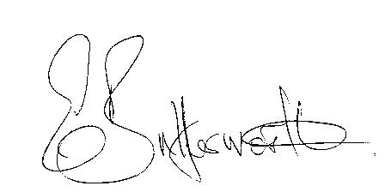Clerk to the Parish Council

BUSINESS TO BE TRANSACTED.

1. Record of Members present.

2. To receive apologies and approve reasons for absence.

3. To receive written requests for Disclosable Pecuniary interests in items on the
agenda.

3. To approve for signature the minutes of the Annual Parish Council meeting and
ordinary meeting held on 24th May 2023 and the extraordinary meeting held on
5th June 2023.

4. Public participation.

5. County and District Councillor reports.

6. Status of current planning applications and to consider planning application
No.23/01657/LBC 4 Old School Lane, Wilmcote: Covering of a small yard to create
a downstairs WC.

Planning application No. 23/01471/LBP The Crofts, 4 Church Road: Concerns and
questions of local residents.

7. Correspondence received and previously circulated will be taken as read.

8. Community Speedwatch update.

9. Willow Wood Play Area.

10. Update on options for a mobile Warm Hub unit in Wilmcote.

11. Pathlow Park Traveller Site update.

12. Councillors’ reports and items for the agenda for the next meeting.

13. Date of next meeting: 20th September 2023

