Parish of Wilmcote

NOTICE OF MEETING OF

PARISH COUNCIL

NOTICE IS HEREBY GIVEN THAT -
A Meeting of the Parish Council for the above named Parish will be held at
WILMCOTE VILLAGE HALL on the 19th September 2018 at 7.30 p.m.

Dated this 13th day of September 2018

Signed:
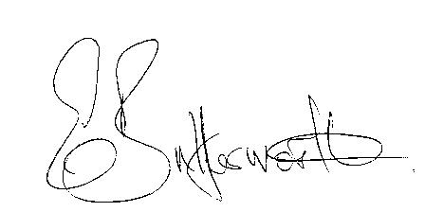Clerk

BUSINESS TO BE TRANSACTED

- Record of Members Present.

- To receive apologies and approve reasons for absence.

- To receive written requests for Disclosable Pecuniary Interests where that interest is not already in the register of members’ interests.

- To approve for signature the Minutes of the Parish Council meeting held on 18th July 2018.

- Public participation.

- County & District Councillor’s reports. For information only. Unless known in advance items raised for a decision will appear on the next agenda.

- Planning Applications – status of current planning applications.

- To consider Planning Application No. 18/02620/TREE 24 Aston Cantlow Road, Wilmcote: Felling of various trees.

- Timeline for responding to planning applications and advice from Cllr. Shilvock on suitable responses.

- Future process for use of Planning Consultant and consideration of type of brief to be provided.

- Cllr. Shilvock report on training session for Planning in the Green Belt.

- Correspondence received:

- Adoption of the Canal Quarter supplementary planning document.
- Community Infrastructure Levy and Permission in Principle.
- Electric Blanket Testing Campaign (1st to 5th October 2018).
- Confirmation from PKF Littlejohn on completion of audit.

- Progress report.

- Willow Wood Play Area update.

- To consider request from SDC to renew the Lease for a further six years on similar terms and conditions as current Lease which expires in February 2019.

- Car parking on Bovis Triangle

- Road Traffic items.
a) Update for Community Speedwatch Scheme.
b) School safety zone.
c) Car parking

- Payment of outstanding invoices.

- Councillors’ reports and items for the agenda for the next meeting.

- Date of next meeting: 21st November 2018.

