Parish of Wilmcote

NOTICE OF MEETING OF

PARISH COUNCIL

NOTICE IS HEREBY GIVEN THAT -
A Meeting of the Parish Council for the above named Parish will be held at
Wilmcote Village Hall on the 20th March 2019 following the Annual Parish meeting.

Dated this 14th day of January 2019

Signed:
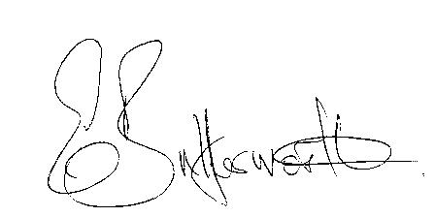Clerk

BUSINESS TO BE TRANSACTED

- Record of Members Present.

- To receive apologies and approve reasons for absence.

- To receive written requests for Disclosable Pecuniary Interests where that interest is not already in the register of members’ interests.

- To approve for signature the Minutes of the Parish Council meeting held on 16th January 2019.
- Resignation of Councillor.

- Public participation.

- County & District Councillor’s reports. For information only. Unless known in advance items raised for a decision will appear on the next agenda.

- Planning Applications – status of current planning applications.

Consideration of Planning Application No. 18/02785/FUL Unit 5 Featherbed Lane, Pathlow: Change of use of building to gymnastics club and dance academy (Use Class D2) and associated café (retrospective).

- Future process for use of Planning Consultant and consideration of type of brief to be provided – update from Cllr. Shilvock.

- Correspondence received:

- Enquiry from Cllr. Horner as to whether Parishes would like
additional roads gritted, at their cost ?

- Progress report.

- Election information including notices and nomination packs.

- Proposed application form for S137 grants.

- Willow Wood Play Area update.
New roundabout.
Future replacement plan for equipment.
New 6 year Lease now in place.
Future Inspections.

- Road Traffic items.
a) Update for Community Speedwatch Scheme.
b) Car parking.
c) Speed limits throughout the village.

- Councillors’ reports and items for the agenda for the next meeting.

- Date of next meeting: 22nd May 2019. Annual General meeting followed by ordinary Parish Council meeting.

