Parish of Wilmcote

NOTICE OF MEETING OF

PARISH COUNCIL

NOTICE IS HEREBY GIVEN THAT -
A Meeting of the Parish Council for the above named Parish will be held at
Wilmcote Village Hall on the 20th May 2015 following the Annual General Meeting.

Dated this 14th day of May 2015

Signed:
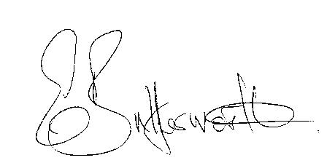Clerk

BUSINESS TO BE TRANSACTED

- Record of Members Present.

- To receive apologies and approve reasons for absence.

- To consider a written request from Mr. McMillan to be co-opted onto the Parish Council.

- To receive written requests for Disclosable Pecuniary Interests where that interest is not already in the register of members’ interests.

- Declarations of dispensations granted for Disclosable Pecuniary Interests already in the register of Members Interests.

- To approve for signature the Minutes of the Annual Parish and ordinary Parish Council meetings on 25th March 2015.

- Public participation.

- County & District Councillor’s reports. For information only. Unless known in advance items raised for a decision will appear on the next agenda.

- Annual Accounts of Wilmcote Parish Council for 2014/15.

- Parish Council Insurance renewal. To consider three quotations for renewal due on 1st June.

- Neighbourhood Plan update.

- Planning Applications – status of current planning applications.

To consider the following planning applications:

Planning Application No. 15/00887/FUL The Long Barn, Birmingham Road, Pathlow: Construction of single stable and haybarn and change of use of land from agricultural to equestrian.

Planning Application No.15/01321/FUL 17 Church road, Wilmcote: Reposition existing vehicular access and driveway.

Planning Application No. 15/01184/FUL 53a Aston Cantlow Road, Wilmcote: Request from the Case Officer for the Parish Council to reconsider our recommendation.

- Progress reports - for information only and items not on the agenda.

- Correspondence received:
-WALC – Legal Briefing Note L02-15 Transparency Code for Smaller Authorities with a turnover not exceeding £25,000
-WALC – 4th edition of the Good Councillors Guide plus addendum.
- WALC Induction training for new Councillors & Clerks.

- Willow Wood Play Area: Update

- Website protocol.

- Stratford on Avon Draft core Strategy update.

- Drainage system in Church Road

- Payment of outstanding invoices.

- Councillors’ reports and items for the agenda for the next meeting.

- Date of next meeting: 15th July 2015.

