Parish of Wilmcote

NOTICE OF MEETING OF

PARISH COUNCIL
A Meeting of the Parish Council for the above named Parish will be held on the 20th May 2020 at 7.30 p.m.

For the health and well-being of our community as a result of the Covid-19 crisis and following the instruction of the Prime Minister’s address on 23rd March 2020, all Parish Council meetings will be held remotely until further notice using Zoom software. All meetings will be recorded using this software.
Should any resident wish to submit a question to the Parish Council or to participate in the meeting via Zoom, please email the Clerk lizbutterworth1@btinternet.com by 2 pm on Monday 18th May.

Dated this 15th day of May 2020

Signed:
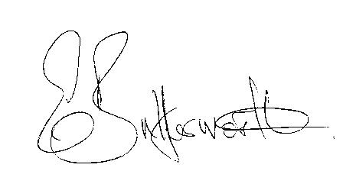Clerk

BUSINESS TO BE TRANSACTED

- Record of Members Present.

- To receive apologies and approve reasons for absence.

- To receive written requests for Disclosable Pecuniary Interests where that interest is not already in the register of members’ interests.

- To approve the Minutes of the Parish Council meeting held on 22nd January 2020.

- Public participation.

- County & District Councillor’s reports. For information only.

- Planning Applications – status of current planning applications.

8. Correspondence: All correspondence sent electronically to date will be taken as
read.

9. Road Traffic Group project.

10. Wilmcote School retaining wall project.

11. S137 Grant Application process for 2020.

12. Date of next meeting to be advised.

