Parish of Wilmcote

NOTICE OF MEETING OF

PARISH COUNCIL

NOTICE IS HEREBY GIVEN THAT -
A Meeting of the Parish Council for the above named Parish will be held at
Wilmcote Village Hall on the 20th July 2016 at 7.30 p.m.

Dated this 14th day of July 2016

Signed:
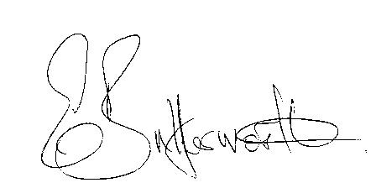Clerk

BUSINESS TO BE TRANSACTED

- Record of Members Present.

- To receive apologies and approve reasons for absence.

- To receive written requests for Disclosable Pecuniary Interests where that interest is not already in the register of members’ interests.

- Parish Councillor resignation.

- To approve for signature the Minutes of the Annual General and ordinary Parish Council meetings on 18th May 2016 and Special Parish Council meeting on 14th June 2016.

- Public participation.

- County & District Councillor’s reports. For information only. Unless known in advance items raised for a decision will appear on the next agenda.

- Planning Applications – status of current planning applications.

To consider Planning Application No. 16/01580/FUL Moor Farm, Billesley Road, Wilmcote: Proposed change of use of land to provide for an extension of horse exercise track and erection of 1.4 metres high post and rail fencing.

- Progress reports - for information only and items not on the agenda.

- Correspondence received:
- E02-16 - NALC and SLCC Salary Scales 2016-18 Final.
- Big Lottery Fund – Awards For All (Lottery Grants of between £300 and £110,00).
- Flying a Flag for Commonwealth Day 2017.
- Stratford District Core Strategy–Publication of Inspector’s final
report.
- Government briefing paper on Fly Tipping.

- Brief report from Cllr. Fraser on “Being a Good Councillor and Clerk” induction day including the following two items to consider whether they would benefit our parish:
- Monthly surgery (2 hours one day) where members of the public can come and talk to a councillor
- Social media presence e.g. Facebook page and Twitter account.

- Standing Orders: To include Parish Council procedure relating to proposals ahead of formal consultation notices from SDC.

- Shakespeare Hospice request to be considered for a charitable donation.

- Willow Wood Play Area update.

- Neighbourhood Plan update.

- Road Traffic items.

- Parish Council Emergency box.

- Payment of outstanding invoices.

- Councillors’ reports and items for the agenda for the next meeting.

- Date of next meeting: 21st September 2016.

