PARISH OF WILMCOTE

Dear Councillor,

You are hereby summoned to attend a meeting of Wilmcote Parish Council to be held at Wilmcote Village Hall on 20th July 2022 at 7.30 pm.

Dated this 15th day of July 2022.
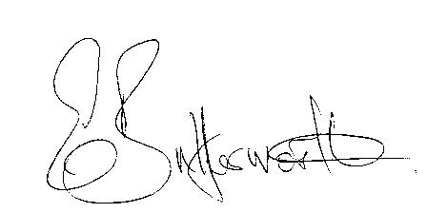Clerk to the Parish Council

BUSINESS TO BE TRANSACTED

- Record of Members Present.

- To receive apologies and approve reasons for absence.

- To receive written requests for Disclosable Pecuniary Interests where that interest is not already in the register of members’ interests.

- To approve for signature the Minutes of the Annual Parish Council meeting and ordinary meeting held on 18th May 2022.

- VAS Church Road.

- Public participation.

- County & District Councillor’s reports.

- Planning Applications – status of current planning applications.

9. Correspondence received and previously circulated electronically will
be taken as read.

10. The Green – verge protection posts.

11. Community Speedwatch update.

12. Willow Wood Play Area update.

13. Pathlow Park Travellers Site update

14. Councillors’ reports and items for the agenda for the next meeting.

15. Date of next meeting: 21st September 2022.

Councillors are reminded of their duty to consider all aspects of equal opportunities, Crime prevention, unlawful discrimination, biodiversity of the
natural habitat, and other best practice when making decisions at the

