Parish of Wilmcote

NOTICE OF MEETING OF

PARISH COUNCIL

NOTICE IS HEREBY GIVEN THAT -
A Meeting of the Parish Council for the above named Parish will be held at
Wilmcote Village Hall on the 20th September 2017 at 7.30 p.m.

Dated this 14th day of September 2017

Signed:
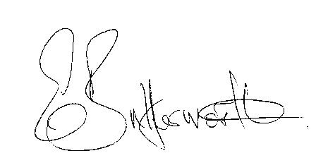Clerk

BUSINESS TO BE TRANSACTED

- Record of Members Present.

- To receive apologies and approve reasons for absence.

- To receive written requests for Disclosable Pecuniary Interests where that interest is not already in the register of members’ interests.

- Co-option of Councillor.

- To approve for signature the Minutes of the Parish Council meeting held on 19th July 2017.

- Public participation.

- County & District Councillor’s reports. For information only. Unless known in advance items raised for a decision will appear on the next agenda.

- Car parking proposals in Wilmcote.

- Planning Applications – status of current planning applications.

- Correspondence received:
- Invitation from the Chairman and Consort of WCC to Open Evening & Reception on 16th September 2017.
- Member training – Community Safety Workshop 21st September 2017.
- Stratford District Member training – Using Social Media for Community Engagement 5th October 2017.
- Wilmcote Parish Council Emergency Plan:

- Willow Wood Play Area update.

- Neighbourhood Plan update.

- Road Traffic items.
a) Update for Community Speedwatch Scheme
b) School safety zone.
c) Vehicles parking on pavement near railway station.

- Payment of outstanding invoices.

- Councillors’ reports and items for the agenda for the next meeting.

- Date of next meeting: 15th November 2017.

