PARISH OF WILMCOTE

A meeting of the Parish Council for the above named Parish will be held in Wilmcote Village Hall on 20th September 2023 at 7.30 pm.

Dated this 15th day of September 2023
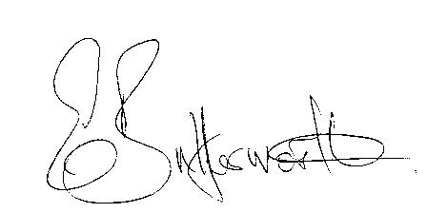Clerk to the Parish Council

BUSINESS TO BE TRANSACTED.

1. Record of Members present.

2. To receive apologies and approve reasons for absence.

3. To receive written requests for Disclosable Pecuniary interests in items on
the agenda.

4. To approve for signature the minutes of the Parish Council meeting
held on 19th July 2023

5. Public participation.

6. County and District Councillor reports.

7. Status of current planning applications and to consider the following:

Planning application No. 23/02354/TREE The Crofts, 5-7 Pear Tree Cottage,
Church Road, Wilmcote. Fell two conifers

Planning application No. 23/02391/FUL 27 Glebe Estate, Wilmcote. Single
storey rear extension.

8. Correspondence received and previously circulated will be taken as read.

9. Mary Arden Inn.

10. Willow Wood Play Area.

11. Community Speedwatch update.

12. Pathlow Park Traveller Site update.

13. Councillors’ reports and items for the agenda for the next meeting.

14. Date of next meeting: 15th November 2023.

