**PARISH OF WILMCOTE**

**A meeting of the Parish Council for the above named Parish will be held at 7.30pm in Wilmcote Village Hall on 20th NOVEMBER 2024.**

Dated this 15th day of November 2024

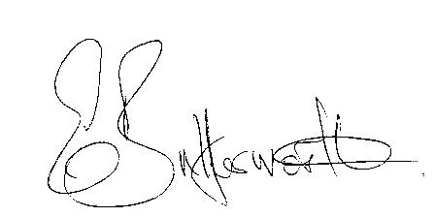Clerk to the Parish Council

**BUSINESS TO BE TRANSACTED**

1. Record of Members present.

2. To receive apologies and approve reasons for absence.

3. To receive written requests for Disclosable Pecuniary interests in items on

the agenda.

4. Cllr Susan Juned, Leader of Stratford District Council

5. Public Participation

6. To approve for signature the minutes of the Parish Council meeting

held on 18th September 2024.

7. County and District Councillor reports.

8. Correspondence received and previously circulated will be taken as read.

9. Status of current planning applications.

10. Barn construction at New House Farm, Pathlow update.

11. Willow Wood Playground progress report.

a) consideration of quotation for roundabout repairs.

b) Heads of Terms relating to new playground lease.

12. Pathlow Park Traveller Site update.

13. Subsidence adjacent to the railway bridge.

14. Community Speedwatch update

15. New Domain names and new Cllr. and Clerk Email addresses.

16. Clerk – Employment contract.

17. Hedge at Mary Arden Inn update

17. Councillors’ reports on items not on the agenda.

18. Items for the agenda for the next meeting.

19. Date of next meeting 22nd January 2025.