Parish of Wilmcote

NOTICE OF MEETING OF

PARISH COUNCIL

NOTICE IS HEREBY GIVEN THAT -
A Meeting of the Parish Council for the above named Parish will be held at
Wilmcote Village Hall on the 21st March 2018 at 7.30 p.m.

Dated this 15th day of March 2018

Signed:
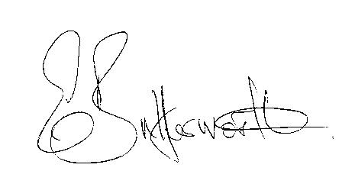Clerk

BUSINESS TO BE TRANSACTED

- Record of Members Present.

- To receive apologies and approve reasons for absence.

- To receive written requests for Disclosable Pecuniary Interests where that interest is not already in the register of members’ interests.

- To approve for signature the Minutes of the Parish Council meeting held on 17th January 2017.

- Public participation.

- County & District Councillor’s reports. For information only. Unless known in advance items raised for a decision will appear on the next agenda.

- Planning Applications – status of current planning applications.
To consider Planning Application No. 17/03676/FUL Turnlea, 13 Old School Lane, Wilmcote: Replacement dormer bungalow together with one additional dwelling.

- Correspondence received:
- Site Allocations Plan for Stratford on Avon District – Intention to prepare a Local
Plan.
- World War 1 Centenary Celebrations.
- Community Infrastructure Levy (CIL) Training for Parish Councillors video of a training session available on the SDC website.
- Notification of Review of Ethical Standards in Local Government.
- Canal Quarter Regeneration Zone Framework Masterplan Supplementary planning document.
- County Church Service to celebrate the Commonwealth.
- Development Requirements Supplementary Planning Document Consultation.
- Wilmcote Parish Council Emergency Plan status.

- Progress report.

- Community Infrastructure Levy – Chairman’s report.

- Willow Wood Play Area update.

- New external auditor appointments.

- New Data Protection Laws guidance and requirements.

- Neighbourhood Plan bank account.

- Road Traffic items.
a) Update for Community Speedwatch Scheme.
b) School safety zone.
c) Vehicles parking on pavement near railway station.

- Payment of outstanding invoices.

- Councillors’ reports and items for the agenda for the next meeting.

- Date of next meeting: 16th May 2018. Annual General meeting followed by ordinary Parish Council meeting.

