PARISH OF WILMCOTE

A meeting of the Parish Council for the above named Parish will be held on 21st July 2021 at 7.30pm in Wilmcote Village Hall

Dated this 16th day of July 2021
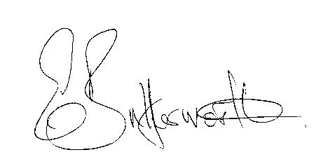Clerk to the Parish Council

BUSINESS TO BE TRANSACTED

- Record of Members Present.

- To receive apologies and approve reasons for absence.

- To receive written requests for Disclosable Pecuniary Interests.

- To approve for signature the minutes of the ordinary Parish Council meeting held on 27th April 2021 and the Annual Parish Council meeting held on 4th May 2021.

- Public participation:

6. Correspondence: All correspondence sent electronically to date will be taken as
read.

7. County and District Councillor reports.

8. Planning applications – status of current applications.

9. Lone Worker Policy.

10. Willow Wood playground update.

11. Application requesting the Mary Arden Inn be added to the list of Community Assets.

12. Road Safety Items: progress of scheme including Westcotec VAS signs.

13. Revised Standing Orders for approval.

14. Community Speedwatch.

15. Items for the agenda for the next meeting.

16. Date of next meetings: 22nd September 2021 and 17th November 2021.

