Parish of Wilmcote

NOTICE OF MEETING OF

PARISH COUNCIL

NOTICE IS HEREBY GIVEN THAT -
A Meeting of the Parish Council for the above named Parish will be held at
Wilmcote Village Hall on the 21st November 2018 at 7.30 p.m.

Dated this 15th day of November 2018

Signed:
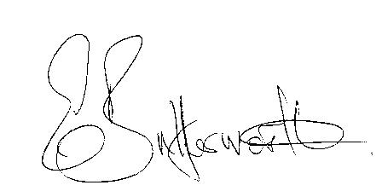Clerk

BUSINESS TO BE TRANSACTED

- Record of Members Present.

- To receive apologies and approve reasons for absence.

- To receive written requests for Disclosable Pecuniary Interests where that interest is not already in the register of members’ interests.

- To approve for signature the Minutes of the Parish Council meeting held on 19th September 2018.

- Public participation.

- County & District Councillor’s reports. For information only. Unless known in advance items raised for a decision will appear on the next agenda.

- Planning Applications – status of current planning applications.

To consider Planning Application No. 18/03124/COUR Unit 1 and Unit 2 Pathlow Farm Buildings, Featherbed Lane, Pathlow: Prior approval for the change of use of part of an agricultural building to uses falling within Classes D2 assembly and leisure (as a flexible use allowed under Class R of Part 3 of the GDPO 2015).

- Future process for use of Planning Consultant and consideration of type of brief to be provided – update from Cllr. Shilvock.

- Correspondence received:

- Draft Statement of Community Involvement – consultation.
- WALC Community Grant Fund – limited to 20% of a project cost.
- Illustrated Parish Maps promotion.
- Notification of adoption of the Canal Quarter SPD.
- Charging of Parish Council Elections for May 2019.
- Chairman's Festive Open Evening Saturday, 1st December 2018.
- Councils VASA funding bid.
- Annual mid-year population estimates.

- Progress report.

- Draft Precept 2019/2020.

- S137 grants.

- Wilmcote Parish Council general purchasing protocol:

- Future Investments in the Parish:

- Willow Wood Play Area update:
Annual Inspection report.
Progress on new roundabout.
Equipment purchasing protocol.

- Road Traffic items.
a) Update for Community Speedwatch Scheme.
b) Car parking.
c) Speed limits throughout the village.

- Payment of outstanding invoices.

- Councillors’ reports and items for the agenda for the next meeting.

- Date of next meeting: 16th January 2019.

