PARISH OF WILMCOTE

A meeting of the Parish Council for the above named Parish will be held on 22nd March 2023 following the Parish Council Annual Assembly which starts at 7.30 pm.

Dated this 17th day of March 2023
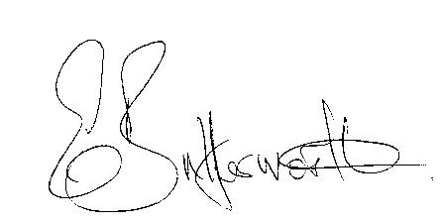Clerk to the Parish Council

BUSINESS TO BE TRANSACTED

- Record of Members Present.

- To receive apologies and approve reasons for absence.

- To receive written requests for Disclosable Pecuniary Interests in items on the agenda.

- To approve for signature the Minutes of the Parish Council meeting held on 25th January 2023 and extraordinary meeting held on the 15th February 2023.

- Public participation.

- County & District Councillor’s reports.

- Draft proposal in connection with land submitted in the District Council’s Call for Sites.

- Community Speedwatch.

9. Correspondence received and previously circulated electronically will
be taken as read.

10. Status of current planning applications.

11. Footway lighting - quotation to renew part night photo electric cells.

12. Willow Wood Play Area update.

13. Defibrillators and defibrillator awareness session

14. Gypsy & Traveller Site Pathlow.

15. Wilmcote School Trust Fund.

16. Lead Councillor responsibilities update – deferred until the May meeting.

17. Quadrennial Parish Elections - 4th May 2023

18. Councillors reports and items for the agenda for the next meeting.

19. Date of next meeting: 24th May 2023. Annual Parish Council meeting
followed by ordinary Parish Council meeting.

