PARISH OF WILMCOTE

A meeting of the Parish Council for the above named Parish will be held on 22nd September 2021 at 7.30pm in Wilmcote Village Hall

Dated this 15th day of September 2021
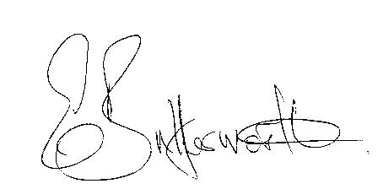Clerk to the Parish Council

BUSINESS TO BE TRANSACTED

- Record of Members Present.

- To receive apologies and approve reasons for absence.

- To receive written requests for Disclosable Pecuniary Interests.

- To approve for signature the minutes of the ordinary Parish Council meeting held on 21st July 2021.

- Nic Allen, Avon Estates, to provide an update on Edkins Park.

- Public participation:

6. Correspondence: All correspondence sent electronically to date will be taken as
read by all Councillors.

7. County and District Councillor reports.

8. Planning applications – status of current applications.

9. Lone Worker Policy.

10. Willow Wood playground update: a) cameras, b) conditions of guarantee, latest inspection
Report etc..

11. Mary Arden Inn: update on application to SDC to add to community asset register.

12. Road Safety Items update: Graham Stanley, WCC hosted a meeting with concerned residents,
agreed to consult with the conservation officer and make investigations into possible
alternatives - no further update available.

13. Consultations:
Proposed merger of SDC & WDC – Participation
Draft recommendations for new ward boundaries across Stratford-on-Avon.

14 E.on footway lighting update.

15. Public participation at Parish Council meetings.

16. Pathlow Park Travellers site update.

17. Zoom: Due to expire in October – consider whether to renew.

18. External Audit report 2020/21.

19. Items for the agenda for the next meeting.

20. Date of next meeting: 17th November 2021.

