Parish of Wilmcote

NOTICE OF MEETING OF

PARISH COUNCIL

NOTICE IS HEREBY GIVEN THAT -
A Meeting of the Parish Council for the above named Parish will be held at
Wilmcote Village Hall on the 23rd March 2016 at 7.30 p.m. following the Annual Parish Meeting.

Dated this 17th day of March 2016

Signed:
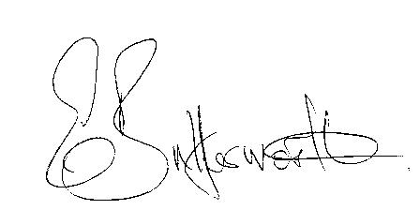Clerk

BUSINESS TO BE TRANSACTED

- Record of Members Present.

- To receive apologies and approve reasons for absence.

- To receive written requests for Disclosable Pecuniary Interests where that interest is not already in the register of members’ interests.

- To approve for signature the Minutes of the meeting held on 27th January 2016 and Special Meeting held on 17th February 2016.
- To consider co-option of new Councillor. A resident from Pathlow has expressed an interest in being co-opted onto the Parish Council.

- Public participation.

- County & District Councillor’s reports. For information only. Unless known in advance items raised for a decision will appear on the next agenda.

- Road Traffic Items.

- Planning Applications – status of current planning applications.

- Progress reports - for information only and items not on the agenda.

- Correspondence received:

- WALC Information on audit regulations.
- Free Home Composting workshops in Warwickshire.
- New Audit scale of fees.

- Parish Council Standing Orders – to agree recommended updates.

- Audit procedures for 2017-18 onwards: To decide whether or not to opt out of the external audit arrangements that Smaller Authorities’ Audit Appointments Ltd. is putting in place. Deadline 31st March 2016.

- Model Financial Regulations revised 21.11.15: To consider for adoption.

- WRCC Housing Needs Survey – to formally agree adoption.

- Willow Wood Play Area Update. To make final decision on replacement equipment based on information obtained by Cllr. McMillan.

- Neighbourhood Plan Update.

- Stratford on Avon Draft Core Strategy update. Examination update March 2016 received.

- Payment of outstanding invoices.

- Councillors’ reports and items for the agenda for the next meeting.

- Date of next meeting: 18th May 2016. Annual General Meeting followed by ordinary Parish Council meeting.

