PARISH OF WILMCOTE

A meeting of the Parish Council for the above named Parish will be held at Wilmcote Village Hall on 23rd NOVEMBER 2022 at 7.30pm

Dated this 18th day of November 2022
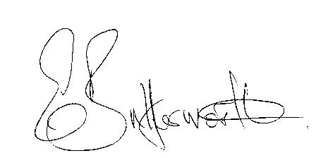Clerk to the Parish Council

BUSINESS TO BE TRANSACTED

- Record of Members Present.

- To receive apologies and approve reasons for absence.

- To receive Declarations of interest in items on the agenda.

- To approve for signature the minutes of the Parish Council meeting held on 5th October 2022.

- Public participation.

- County & District Councillor’s reports.

- Planning Applications – status of current planning applications and
to consider the following applications

Application No. 22/03111/FUL Moat Orchard, Old School Lane, Wilmcote. Minor enlarging of existing garage.

Application No. DISC/00481/22 Palmers Farmhouse, The Great Barn, Station Road, Wilmcote, CV37 9UN. Discharge of condition on proposed stone attached to application 20/00114/LBC.

8. Correspondence received and previously circulated electronically will
be taken as read.

9. Community Speedwatch update.

10. Willow Wood Play Area update.

11. Draft Precept.

12. Wilmcote Parish Council Grant Fund applications.

13. WRCC funding for Community Groups to set up a ‘Warm Hub’.

15. Councillors’ reports and items for the agenda for the next meeting.

16. Date of next meeting: 25th January 2023.

