PARISH OF WILMCOTE

A meeting of the Parish Council for the above named Parish will be held at Wilmcote Village Hall on 24th January 2024 at 7.30pm

Dated this 19th day of January 2024
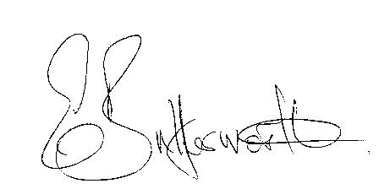Clerk to the Parish Council

BUSINESS TO BE TRANSACTED

1. Record of Members present.

2. To receive apologies and approve reasons for absence.

3. To receive written requests for Disclosable Pecuniary interests in items on
the agenda.

4. To approve for signature the minutes of the Parish Council meeting
held on 13th November 2023.

5. Public participation.

6. County and District Councillor reports.

7. To agree precept figure for 2024-2025.

8. Status of current planning applications.

9. Correspondence received and previously circulated will be taken as read.

10. Mary Arden Inn update.

11. Willow Wood Play Area update.

12. Sarah Brooke-Taylor, WRCC. 2015 Housing Needs Survey data no longer relevant – do we want to undertake a new survey?

13. Warwickshire Rights of Way Improvement Plan Survey questionnaire.

14. Request from the History Society for a notice board at the junction of Glebe Estate/Aston Road to replace the one that was removed some time ago.

15. Community Speedwatch update.

16. Parish Council Grant Fund applications 2024/2025

17. Pathlow Park Traveller Site update.

18. Councillors’ reports: Planning Training Session 11th January

19. Items for the agenda for the next meeting.

20. Date of next meeting: 20th March 2024. Annual Parish Assembly followed by an ordinary parish council meeting.

