PARISH OF WILMCOTE

A meeting of the Parish Council for the above named Parish will be held on 25th January 2023 at 7.30pm in Wilmcote Village Hall

Dated this 21st day of January 2023
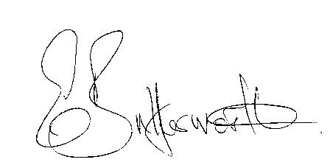Clerk to the Parish Council

BUSINESS TO BE TRANSACTED

- Record of Members Present.

- To receive apologies and approve reasons for absence.

- To receive written requests for Disclosable Pecuniary Interests.

- To approve for signature the previously circulated minutes of the ordinary Parish Council meeting held on 23rd November 2022 and Extraordinary meeting held on 16th December 2022

- Public participation.

- County and District Councillor reports.

- Status of current Planning Applications.

- Correspondence received and previously circulated will be taken as read.

9. To formally agree the precept request for 2023/2024. A proposal was circulated to Councillors
for consideration ahead of the meeting.

10. Community Speedwatch update.

11. Willow Wood Play Area.

12. Wilmcote Parish Council Grant Fund applications.

13. To investigate further options for a Warm Hub in the Parish.

14. Footway lighting contract due for renewal 1st March 2023.

15. Councillors’ reports and items for the agenda for the next meeting.

16. Lead Councillors’ responsibilities update.

17. Date of next meeting: 22nd March 2023 Annual Parish Assembly followed by ordinary
Parish Council meeting.

