Parish of Wilmcote

NOTICE OF MEETING OF

PARISH COUNCIL
A Meeting of the Parish Council for the above named Parish will be held on the 30th September 2020 at 7.00 p.m.

For the health and well-being of our community as a result of the Covid-19 crisis and following the instruction of the Prime Minister’s address on 23rd March 2020, all Parish Council meetings will be held remotely until further notice using Zoom software. All meetings will be minuted.
Should any resident wish to submit a question to the Parish Council or to participate in the meeting via Zoom, please email the Clerk lizbutterworth1@btinternet.com by 2 pm on Monday 3rd August.

Dated this 24th day of September 2020

Signed:
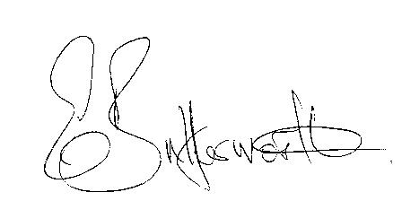Clerk

BUSINESS TO BE TRANSACTED

- Record of Members Present.

- To receive apologies and approve reasons for absence.

- To receive written requests for Disclosable Pecuniary Interests.

- To approve for signature the minutes of the Parish Council meeting held on 4th August 2020

- Public participation

6. Correspondence: All correspondence sent electronically to date will be taken as
read.

7. County and District Councillor reports

8. Planning applications – status of current applications.
Heart of England Forests - recent purchase of land in Wilmcote and Bearley
Changes to the planning process

9. Wilmcote School retaining wall project

10. Unitary Authorities

11. My Local Bobby

12. Standing Orders – Procedure for Cllrs. to pay site visits when required.

13. Shakespeare Line Promotion Group- Wilmcote Station

14. Road traffic items
a) Church Road safety
b) Area between train station and canal entrance
c) Localities Officer
d) ANPR cameras

15. Willow Wood playground
a) September inspection report
b) Notice board

16. Gypsy & Traveller plan

17. Request for possible site to place a bench in memory of Pauline Scruby

18. Speedwatch update from Paul Yates

19. Zoom – is there a need for the Parish Council to purchase.

20. Notification of Local Government Services pay agreement 2020-21

21. Items for the agenda for the next meeting.

22. Date of next meeting 18th November 2020

