PARISH OF WILMCOTE

NOTICE OF MEETING OF PARISH COUNCIL

Dear Councillor

You are hereby summoned to attend a meeting of Wilmcote Parish Council to be held at Wilmcote Village Hall on 21st May 2025 at 7.30 p.m. for the purpose of transacting the following business.

Dated this 17th day of May 2025
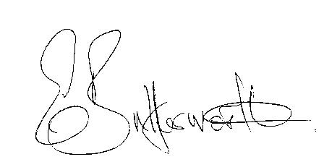Clerk to the Parish Council

WILMCOTE PARISH COUNCIL ANNUAL MEETING

AGENDA

Election of Chairman
Record of members present
Apologies for Absence
To receive the Chairman’s Declaration of Acceptance of Office
To receive declarations of acceptance of office and completed Registers of Interests from two new members of the council, Cllr Lee and Cllr Bates
Declarations of Interests in items on the agenda
Election of Vice Chairman if required
Appointment of Internal Auditor
Statement of Finances as at 31st March 2025
Approve following standard items included in Precept for payment:

HMRC PAYE & NI - Quarterly
Clerk’s salary - monthly
WALC subs – annual
SDC Website hosting – annual
Npower energy
E.on maintenance
Insurance - annual
G. Compton for grass cutting – The Green
Auditors - internal and external – annual
S137 grants once agreed by Cllrs - annual
ICO annual
CPRE annual

PLAYGROUND
Gary Compton – grass and hedge cutting plus litter picking
SDC Lease 6 monthly
Monthly inspections
Annual inspection

Followed by

ORDINARY PARISH COUNCIL MEETING

- Declaration of disclosable pecuniary interests in items on the agenda.

- To approve for signature the minutes of the Annual Parish Assembly meeting and ordinary meeting held on 19th March 2025.

- Public participation.

- County & District Councillors reports.

- Annual Accounts of Wilmcote Parish Council for 2024/2025.
a) Annual Governance statement.
b) Accounting Statements.

- Planning Applications update.

- Correspondence received and previously circulated will be taken as read.

- Existing vacancy.

9. Lead Councillor responsibilities update.

10. Webmaster to maintain/update parish council website.

11. Proposed price increases for mowing The Green, Willow Wood Play
Area mowing, strimming and hedge cutting.

12. Willow Wood play area – new Lease for signature

13. Wilmcote station bench replacement project.

14. Adoption of BT telephone kiosk on The Green.

15. PC Domain names and new email addresses.

16. Update on Shakespeare Birthplace Trust.

17. SWLP joint funding with Bearley Parish Council for possible professional help.

18. Councillors reports and items for the agenda for the next meeting.

19. Date of next meeting: 16th July 2025.

REMINDER Meetings of the Parish Council are not public meetings. Members of the public have a statutory right to attend as observers. Agenda item No 3 is set for public participation. Members of the public should not be involved in decision making and the Council should not make any instant decisions at the behest of members of the public on items not included in the agenda.

