NOTICE OF EXTRAORDINARY MEETING
OF PARISH COUNCIL

A meeting of the Parish Council will be held in Wilmcote Village Hall on the 14th September 2022 at 7.30 p.m.

BUSINESS TO BE TRANSACTED

- Present

- Apologies for absence

- To receive written requests for Disclosable Pecuniary Interests.

4. To consider Planning Application No. 22/02236/FUL 6 Marsh Road, Wilmcote: Demolition of existing dwelling and replacement with a single dwelling to be self-build and all other associated works.

Dated this 7th day of September 2022
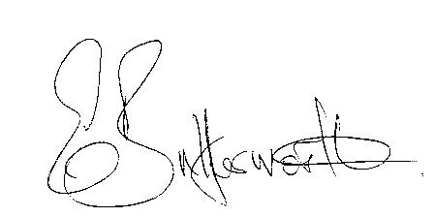Clerk

