NOTICE OF EXTRAORDINARY MEETING
OF PARISH COUNCIL

A meeting of the Parish Council will be held in Wilmcote Village Hall on the 15th February 2022 at 7.00 p.m.

BUSINESS TO BE TRANSACTED

- Present.

- Apologies for absence.

- To receive written requests for Disclosable Pecuniary Interests.

4. Public participation.

5. To consider planning application No. 23/00228/FUL 113 Aston Cantlow Road, Wilmcote: Proposed extensions, replacement fenestration, roof coverings and elevational treatments.

6. South Warwickshire Local Plan. To consider and agree responses to the
Consultation.

Dated this 10th day of February 2023
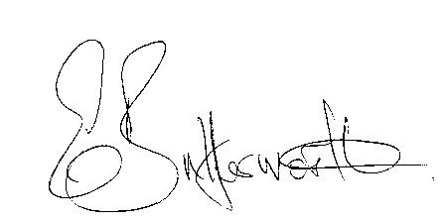Clerk

