NOTICE OF EXTRAORDINARY MEETING
OF PARISH COUNCIL

A meeting of the Parish Council will be held in Wilmcote Village Hall on the 16th December 2022 at 7.00 p.m.

BUSINESS TO BE TRANSACTED

- Present.

- Apologies for absence.

- To receive written requests for Disclosable Pecuniary Interests.

4. Public participation.

5. Masons Arms, Wilmcote. To view proposed revised plans prior to
submission.

Dated this 11th day of December 2022
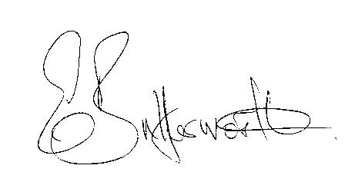Clerk

