NOTICE OF EXTRAORDINARY MEETING
OF PARISH COUNCIL

A meeting of the Parish Council will be held in Wilmcote Village Hall on the 17th August 2022 at 7.30 p.m.

BUSINESS TO BE TRANSACTED

- Present

- Apologies for absence

- To receive written requests for Disclosable Pecuniary Interests.

- Church Road Vehicle Activated Sign.
This item has been discussed at previous Parish Council meetings and it is proposed that a final decision is reached on this occasion. Mr. Stanley, County Highways Officer, is expected to attend.

Dated this 12th day of August 2022
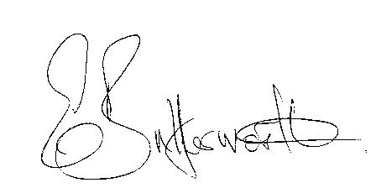Clerk

