WILMCOTE PARISH COUNCIL

ANNUAL GENERAL MEETING

To be held on 17th May 2017 in Wilmcote Village Hall at 7.30 p.m.

Signed 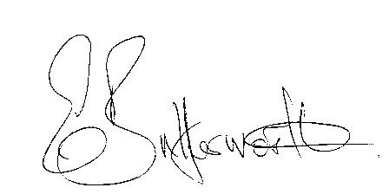
Clerk to the Council 11th May 2017

AGENDA

Election of Chairman
Record of members present
Apologies for Absence
To receive the Chairman’s Declaration of Acceptance of Office
Election of Vice Chairman if required
Appointment of Internal Auditor
Statement of Finances as at 31st March 2017
Approve following annual accounts for payment:
WALC annual subscription
Insurance renewal premium
Data protection
CPRE subscription
Audit fees
Clerk’s salary and accounting to the Inland Revenue for all tax deducted

