WILMCOTE PARISH COUNCIL

ANNUAL GENERAL MEETING

To be held on 18th May 2016 in Wilmcote Village Hall at 7.30 p.m.

Signed 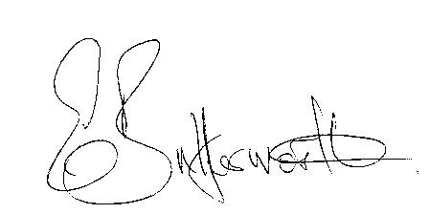
Clerk to the Council 10th May 2015

AGENDA

Election of Chairman
Record of members present
Apologies for Absence
To receive the Chairman’s Declaration of Acceptance of Office
To approve for signature the Minutes of the AGM 20th May 2015
Election of Vice Chairman if required
Appointment of Internal Auditor
Statement of Finances as at 31st March 2016
Approve following annual accounts for payment:
WALC annual subscription
Insurance renewal premium
Data protection
CPRE subscription
Audit fees
Clerk’s salary and accounting to the Inland Revenue for all tax deducted

