WILMCOTE PARISH COUNCIL

ANNUAL GENERAL MEETING

To be held on 20th May 2015 in Wilmcote Village Hall at 7.30 p.m.

Signed 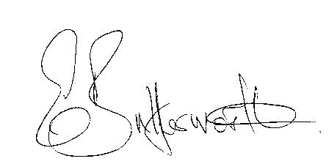
Clerk to the Council 14th May 2015

AGENDA

Election of Chairman
Record of members present
Apologies for Absence
To receive the Chairman’s Declaration of Acceptance of Office
To receive all Councillor’s Declarations of Acceptance of Office
To receive all Councillor’s Register of Members’ Interests forms
To approve for signature the Minutes of the AGM 21st May 2014
Election of Vice Chairman
Appointment of Internal Auditor
To agree cheque signatories and sign appropriate Bank Mandate
Statement of Finances as at 31st March 2015
Approve following annual accounts for payment:
WALC annual subscription
Insurance renewal premium
Data protection
CPRE subscription
Audit fees
Clerk’s salary and accounting to the Inland Revenue for all tax deducted

