WILMCOTE PARISH COUNCIL

ANNUAL GENERAL MEETING

To be held on 21st May 2014 in Wilmcote Village Hall at 7.30 p.m.

Signed 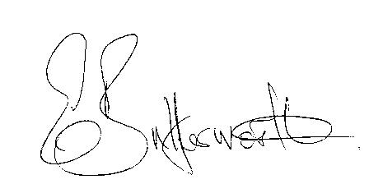
Clerk to the Council 16th May 2014

AGENDA

Present
Election of Chairman
Apologies for Absence
Members Declaration of Disclosable Pecuniary Interests
To receive the Chairman’s Declaration of Acceptance of Office
Election of Vice Chairman
Appointment of Internal Auditor
Statement of Finances as at 31st March 2014
Approve following annual accounts for Payment:
WALC annual subscription
Insurance renewal Premium
Data Protection
CPRE
Audit fees
Clerk’s salary and accounting to the Inland Revenue for all tax deducted.

