PARISH OF WILMCOTE

NOTICE OF MEETING OF PARISH COUNCIL

Dear Sir/Madam,

You are hereby summoned to attend a meeting of Wilmcote Parish Council to be held at Wilmcote Village Hall on 22nd May 2019 at 7.30 p.m. for the purpose of transacting the following business.

Dated this 16th day of May 2019
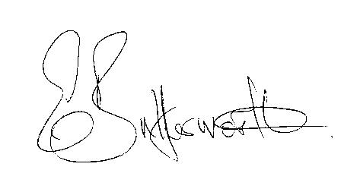Clerk to the Parish Council

WILMCOTE PARISH COUNCIL ANNUAL MEETING

AGENDA

Election of Chairman
Record of members present
Apologies for Absence
To receive the Chairman’s Declaration of Acceptance of Office
To receive the Councillors’ Declarations of Acceptance of Office
Declaration by Councillors of any changes to their Declarations of Interest as shown on the public register.
Election of Vice Chairman if required
Appointment of Internal Auditor
Statement of Finances as at 31st March 2019
Approve following annual accounts for payment:
WALC annual subscription
Insurance renewal premium
Data protection
CPRE subscription
Audit fees
Clerk’s salary and accounting to the Inland Revenue for all tax deducted

Followed by

ORDINARY PARISH COUNCIL MEETING

- To receive written requests for Disclosable Pecuniary Interests where that interest is not already in the register of members’ interests.+
- To approve for signature the minutes of the Annual Parish meeting and ordinary Parish Council meeting held on 20th March 2019.

- Co-option of three new Councillors

- Public participation.

- County & District Councillor’s reports.

- Annual Accounts of Wilmcote Parish Council for 2018/19.

- Progress reports - for information only and items not on the agenda.

- Planning Applications – status of current planning applications.

Consideration of Planning Application No. 19/01025/FUL Dunroaming Stable, Gospel Oak Lane, Pathlow: Application fort second mobile home and shared utility block with associated hard standing on existing Gypsy Traveller site.

- Correspondence received:

- Parish Council election results of persons nominated.
- District Councillors’ election results of person nominated.

- Consideration of Councillor participation and responsibilities.

- Wilmcote School Trust Fund

- Willow Wood Play Area update:
Future inspections.
Equipment for the future.

- Road Traffic items:
Speed limits throughout the village of Wilmcote
Community Speedwatch
Car parking

- Councillors’ reports and items for the agenda for the next meeting.

- Date of next meeting: 17th July 2019.

Councillors are reminded of their duty to consider all aspects of equal opportunities,Crime prevention, unlawful discrimination, biodiversity of the
natural habitat, and other best practice when making decisions at the meeting.

